**MBAN 6120 Assignment 3**

**Chapter 8 Level I and II Exercises**

1 a) b)

**data** work.newemployees;

length First $ **12** Last $ **18** Title $ **25**;

infile "&path\newemps.csv" dlm = ',';

input First $ Last $ Title $ Salary;

**run**;

NOTE: The infile "c:\sas\prg1\newemps.csv" is:

Filename=c:\sas\prg1\newemps.csv,

RECFM=V,LRECL=32767,File Size (bytes)=5822,

Last Modified=September 20, 2015 23:55:06 o',

Create Time=September 14, 2015 15:01:11 o'

NOTE: 71 records were read from the infile "c:\sas\prg1\newemps.csv".

The minimum record length was 80.

The maximum record length was 80.

NOTE: The data set WORK.NEWEMPLOYEES has 71 observations and 4 variables.

NOTE: DATA statement used (Total process time):

real time 0.12 seconds

cpu time 0.01 seconds

c)

**proc** **print** data = work.newemployees;

**run**;

NOTE: There were 71 observations read from the data set WORK.NEWEMPLOYEES.

NOTE: PROCEDURE PRINT used (Total process time):

real time 0.53 seconds

cpu time 0.18 seconds

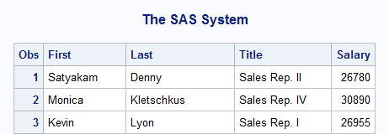

2 a) b)

**data** work.qtrdonation;

length IDNum $ **6**;

infile "&path\donation.dat";

input IDNum $ Qtr1 Qtr2 Qtr3 Qtr4;

**run**;

NOTE: The infile "c:\sas\prg1\donation.dat" is:

Filename=c:\sas\prg1\donation.dat,

RECFM=V,LRECL=32767,File Size (bytes)=10168,

Last Modified=September 20, 2015 23:55:06 o',

Create Time=September 14, 2015 15:01:11 o'

NOTE: 124 records were read from the infile "c:\sas\prg1\donation.dat".

The minimum record length was 80.

The maximum record length was 80.

NOTE: The data set WORK.QTRDONATION has 124 observations and 5 variables.

NOTE: DATA statement used (Total process time):

real time 0.01 seconds

cpu time 0.00 seconds

c)

**proc** **print** data=work.qtrdonation;

**run**;

NOTE: There were 124 observations read from the data set WORK.QTRDONATION.

NOTE: PROCEDURE PRINT used (Total process time):

real time 0.46 seconds

cpu time 0.15 seconds

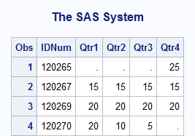

4 a)

**data** work.canada_customers;

length First Last $ **20** Gender $ **1** AgeGroup $ **12**;

infile "&path\custca.csv" dlm = ',';

input First $ Last $ ID Gender $

BirthDate :ddmmyy. Age AgeGroup $;

**run**;

NOTE: The infile "c:\sas\prg1\custca.csv" is:

Filename=c:\sas\prg1\custca.csv,

RECFM=V,LRECL=32767,File Size (bytes)=1230,

Last Modified=September 20, 2015 23:55:06 o',

Create Time=September 14, 2015 15:01:10 o'

NOTE: 15 records were read from the infile "c:\sas\prg1\custca.csv".

The minimum record length was 80.

The maximum record length was 80.

NOTE: The data set WORK.CANADA_CUSTOMERS has 15 observations and 7 variables.

NOTE: DATA statement used (Total process time):

real time 0.01 seconds

cpu time 0.01 seconds

b)

**data** work.canada_customers;

length First Last $ **20** Gender $ **1** AgeGroup $ **12**;

infile "&path\custca.csv" dlm = ',';

input First $ Last $ ID Gender $

BirthDate :ddmmyy. Age AgeGroup $;

format BirthDate monyy7.;

drop ID Age;

**run**;

title 'Canadian Customers';

**proc** **print** data = work.canada_customers;

**run**;

title;

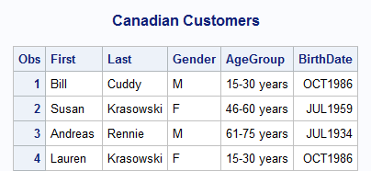

5 a)

**data** work.prices;

infile "&path\pricing.dat" dlm = '*';

input ProductID StartDate :date. EndDate :date.

Cost :dollar. SalesPrice :dollar.;

format StartDate EndDate mmddyy10.

Cost SalesPrice **8.2**;

**run**;

NOTE: The infile "c:\sas\prg1\pricing.dat" is:

Filename=c:\sas\prg1\pricing.dat,

RECFM=V,LRECL=32767,File Size (bytes)=1312,

Last Modified=September 20, 2015 23:55:06 o',

Create Time=September 14, 2015 15:01:16 o'

NOTE: 16 records were read from the infile "c:\sas\prg1\pricing.dat".

The minimum record length was 80.

The maximum record length was 80.

NOTE: The data set WORK.PRICES has 16 observations and 5 variables.

NOTE: DATA statement used (Total process time):

real time 0.06 seconds

cpu time 0.00 seconds

b)

title '2011 Pricing';

**proc** **print** data = work.prices;

**run**;

title;

NOTE: There were 16 observations read from the data set WORK.PRICES.

NOTE: PROCEDURE PRINT used (Total process time):

real time 0.42 seconds

cpu time 0.12 seconds

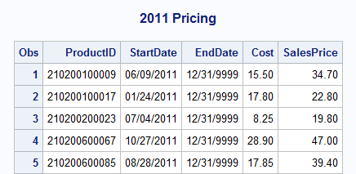

7 a) b)

**data** work.donations;

infile "&path\donation.csv" dsd missover;

input EmpID Q1 Q2 Q3 Q4;

**run**;

NOTE: The infile "c:\sas\prg1\donation.csv" is:

Filename=c:\sas\prg1\donation.csv,

RECFM=V,LRECL=32767,File Size (bytes)=10168,

Last Modified=September 20, 2015 23:55:06 o',

Create Time=September 14, 2015 15:01:11 o'

NOTE: 124 records were read from the infile "c:\sas\prg1\donation.csv".

The minimum record length was 80.

The maximum record length was 80.

NOTE: The data set WORK.DONATIONS has 124 observations and 5 variables.

NOTE: DATA statement used (Total process time):

real time 0.03 seconds

cpu time 0.01 seconds

c)

**proc** **print** data = work.donations;

**run**;

NOTE: There were 124 observations read from the data set WORK.DONATIONS.

NOTE: PROCEDURE PRINT used (Total process time):

real time 0.48 seconds

cpu time 0.15 seconds

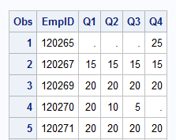

8 a)

**data** work.prices;

infile "&path\prices.dat" dlm = '*' missover;

Input ProductID StartDate :date. EndDate :date.

UnitCostPrice :dollar. UnitSalesPrice :dollar.;

**run**;

8 a)

NOTE: The infile "c:\sas\prg1\prices.dat" is:

Filename=c:\sas\prg1\prices.dat,

RECFM=V,LRECL=32767,File Size (bytes)=21238,

Last Modified=September 20, 2015 23:55:06 o',

Create Time=September 14, 2015 15:01:16 o'

NOTE: 259 records were read from the infile "c:\sas\prg1\prices.dat".

The minimum record length was 80.

The maximum record length was 80.

NOTE: The data set WORK.PRICES has 259 observations and 5 variables.

NOTE: DATA statement used (Total process time):

real time 0.03 seconds

cpu time 0.00 seconds

b)

**data** work.prices;

infile "&path\prices.dat" dlm = '*' missover;

input ProductID StartDate :date. EndDate :date.

UnitCostPrice :dollar. UnitSalesPrice :dollar.;

label ProductID = 'Product ID'

StartDate = 'Start of Date Range'

EndDate = 'End of Date Range'

UnitCostPrice = 'Cost Price per Unit'

UnitSalesPrice = 'Sales Price per Unit';

format StartDate EndDate mmddyy10.

UnitCostPrice UnitSalesPrice **8.2**;

**run**;

title '2007 Prices';

**proc** **print** data = work.prices label;

**run**;

title;

NOTE: There were 259 observations read from the data set WORK.PRICES.

NOTE: PROCEDURE PRINT used (Total process time):

real time 0.53 seconds

cpu time 0.18 seconds

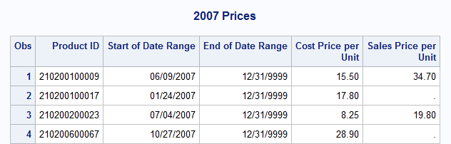

**Chapter 9 Level I and II Exercises**

1 a) b)

**proc** **contents** data = orion.staff;

**run**;

**data** work.increase;

set orion.staff;

Increase = Salary * **0.10**;

NewSalary = Salary + Increase;

BdayQtr = qtr(Birth_Date);

**run**;

c)

**data** work.increase;

set orion.staff;

Increase = Salary * **0.10**;

NewSalary = Salary + Increase;

BdayQtr = qtr(Birth_Date);

keep Employee_ID Salary Birth_Date Increase NewSalary BdayQtr;

**run**;

d)

**data** work.increase;

set orion.staff;

Increase = Salary * **0.10**;

NewSalary = Salary + Increase;

BdayQtr = qtr(Birth_Date);

keep Employee_ID Salary Birth_Date Increase NewSalary BdayQtr;

format Salary Increase NewSalary comma8.;

**run**;

e)

**proc** **print** data=work.increase label;

**run**;

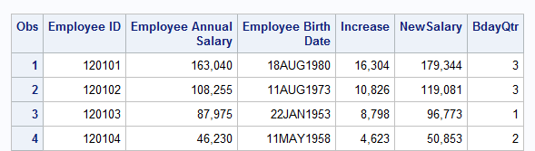

2 a)

**data** work.birthday;

set orion.customer;

**run**;

b)

**data** work.birthday;

set orion.customer;

Bday2012 = mdy(month(Birth_Date), day(Birth_Date), **2012**);

BdayDOW2012 = weekday(Bday2012);

Age2012 = (Bday2012 - Birth_Date) / **365.25**;

**run**;

c)

**data** work.birthday;

set orion.customer;

Bday2012 = mdy(month(Birth_Date), day(Birth_Date), **2012**);

BdayDOW2012 = weekday(Bday2012);

Age2012 = (Bday2012 - Birth_Date) / **365.25**;

keep Customer_Name Birth_Date Bday2012 BdayDOW2012 Age2012;

**run**;

d)

**data** work.birthday;

set orion.customer;

Bday2012 = mdy(month(Birth_Date), day(Birth_Date), **2012**);

BdayDOW2012 = weekday(Bday2012);

Age2012 = (Bday2012 - Birth_Date) / **365.25**;

keep Customer_Name Birth_Date Bday2012 BdayDOW2012 Age2012;

format Bday2012 date9. Age2012 **3.**;

**run**;

NOTE: There were 77 observations read from the data set ORION.CUSTOMER.

NOTE: The data set WORK.BIRTHDAY has 77 observations and 5 variables.

NOTE: DATA statement used (Total process time):

real time 0.57 seconds

cpu time 0.01 seconds

e)

**proc** **print** data = work.birthday;

**run**;

NOTE: There were 77 observations read from the data set WORK.BIRTHDAY.

NOTE: PROCEDURE PRINT used (Total process time):

real time 1.44 seconds

cpu time 0.26 seconds

2 e)

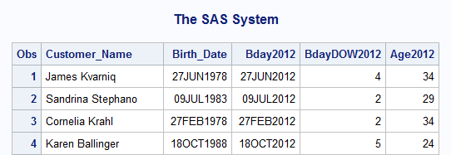

4 a) b)

**data** work.ordertype;

set orion.orders;

length Method $ **8**;

if Order_Type = **1**

then Method = 'Retail';

else if Order_Type = **2**

then Method = 'Catalog';

else if Order_type = **3**

then Method = 'Internet';

else

Method = 'Unknown';

**run**;

c)

**proc** **print** data = work.ordertype;

var Order_ID Order_Type Method;

**run**;

NOTE: There were 490 observations read from the data set WORK.ORDERTYPE.

NOTE: PROCEDURE PRINT used (Total process time):

real time 0.58 seconds

cpu time 0.26 seconds

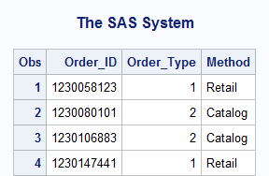

5 a) b)

**data** work.region;

set orion.supplier;

length Region $ **17**;

if Country in ('CA','US') then do;

Discount = **0.10**;

DiscountType = 'Required';

Region = 'North America';

end;

else do;

Discount = **0.05**;

DiscountType = 'Optional';

Region = 'Not North America';

end;

**run**;

c)

**data** work.region;

set orion.supplier;

length Region $ **17**;

if Country in ('CA','US') then do;

Discount = **0.10**;

DiscountType = 'Required';

Region = 'North America';

end;

else do;

Discount = **0.05**;

DiscountType = 'Optional';

Region = 'Not North America';

end;

keep Supplier_Name Country Discount DiscountType Region;

**run**;

NOTE: There were 52 observations read from the data set ORION.SUPPLIER.

NOTE: The data set WORK.REGION has 52 observations and 5 variables.

NOTE: DATA statement used (Total process time):

real time 0.07 seconds

cpu time 0.01 seconds

d)

**proc** **print** data = work.region;

**run**;

NOTE: There were 52 observations read from the data set WORK.REGION.

NOTE: PROCEDURE PRINT used (Total process time):

real time 0.42 seconds

cpu time 0.09 seconds

5 d)

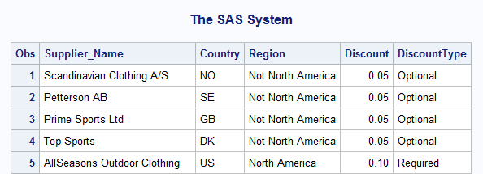

6 a)

**data** work.season;

set orion.customer_dim;

**run**;

NOTE: There were 77 observations read from the data set ORION.CUSTOMER_DIM.

NOTE: The data set WORK.SEASON has 77 observations and 11 variables.

NOTE: DATA statement used (Total process time):

real time 0.03 seconds

cpu time 0.01 seconds

b)

**data** work.season;

set orion.customer_dim;

length Promo2 $ **6**;

Quarter = qtr(Customer_BirthDate);

if Quarter = **1**

then Promo = 'Winter';

else if Quarter = **2**

then Promo = 'Spring';

else if Quarter = **3**

then Promo = 'Summer';

else if Quarter = **4**

then Promo = 'Fall';

if Customer_Age >= **18** and Customer_Age <= **25**

then Promo2 = 'YA';

else if Customer_Age >= **65**

then Promo2 = 'Senior';

**run**;

6 c)

**data** work.season;

set orion.customer_dim;

length Promo2 $ **6**;

Quarter = qtr(Customer_BirthDate);

if Quarter = **1**

then Promo = 'Winter';

else if Quarter = **2**

then Promo = 'Spring';

else if Quarter = **3**

then Promo = 'Summer';

else if Quarter = **4**

then Promo = 'Fall';

if Customer_Age >= **18** and Customer_Age <= **25**

then Promo2 = 'YA';

else if Customer_Age >= **65**

then Promo2 = 'Senior';

keep Customer_FirstName Customer_LastName Customer_BirthDate

Customer_Age Promo Promo2;

**run**;

NOTE: There were 77 observations read from the data set ORION.CUSTOMER_DIM.

NOTE: The data set WORK.SEASON has 77 observations and 6 variables.

NOTE: DATA statement used (Total process time):

real time 0.01 seconds

cpu time 0.00 seconds  
 d)

**proc** **print** data = work.season;

var Customer_FirstName Customer_LastName Customer_BirthDate Promo

Customer_Age Promo2;

**run**;

NOTE: There were 77 observations read from the data set WORK.SEASON.

NOTE: PROCEDURE PRINT used (Total process time):

real time 0.06 seconds

cpu time 0.04 seconds

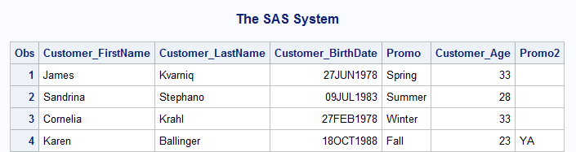

7 a)

**data** work.ordertype;

set orion.orders;

**run**;

NOTE: There were 490 observations read from the data set ORION.ORDERS.

NOTE: The data set WORK.ORDERTYPE has 490 observations and 6 variables.

NOTE: DATA statement used (Total process time):

real time 0.01 seconds

cpu time 0.01 seconds

b)

**data** work.ordertype;

set orion.orders;

DayOfWeek = weekday(Order_Date);

**run**;

c)

**data** work.ordertype;

set orion.orders;

length Type $ **13**;

DayOfWeek = weekday(Order_Date);

if Order_Type = **1** then

Type = 'Retail Sale';

else if Order_Type = **2** then

Type = 'Catalog Sale';

else if Order_Type = **3** then

Type = 'Internet Sale';

**run**;

d)

**data** work.ordertype;

set orion.orders;

length Type $ **13** SaleAds $ **5**;

DayOfWeek = weekday(Order_Date);

if Order_Type = **1** then

Type = 'Retail Sale';

else if Order_Type = **2** then do;

Type = 'Catalog Sale';

SaleAds = 'Mail';

end;

else if Order_Type = **3** then do;

Type = 'Internet Sale';

SaleAds = 'Email';

end;

**run**;

7 e)

**data** work.ordertype;

set orion.orders;

length Type $ **13** SaleAds $ **5**;

DayOfWeek = weekday(Order_Date);

if Order_Type = **1** then

Type = 'Retail Sale';

else if Order_Type = **2** then do;

Type = 'Catalog Sale';

SaleAds = 'Mail';

end;

else if Order_Type = **3** then do;

Type = 'Internet Sale';

SaleAds = 'Email';

end;

drop Order_Type Employee_ID Customer_ID;

**run**;

NOTE: There were 490 observations read from the data set ORION.ORDERS.

NOTE: The data set WORK.ORDERTYPE has 490 observations and 6 variables.

NOTE: DATA statement used (Total process time):

real time 0.01 seconds

cpu time 0.01 seconds

f)

**proc** **print** data = work.ordertype;

**run**;

NOTE: There were 490 observations read from the data set WORK.ORDERTYPE.

NOTE: PROCEDURE PRINT used (Total process time):

real time 0.60 seconds

cpu time 0.31 seconds

